1. Procedure which does group by information:

DECLARE

CURSOR cur_order IS

SELECT REPORT_DATE, COUNT(REPORT_ID) AS count_res

FROM TRANSACTION_REPORT

GROUP BY REPORT_DATE;

BEGIN

FOR rec_order IN cur_order LOOP

dbms_output.put_line('Report date: ' || rec_order.REPORT_DATE || ', Result: ' || rec_order.count_res);

END loop;

END;

// Using this procedure, we can get information about how many reports were on a certain date

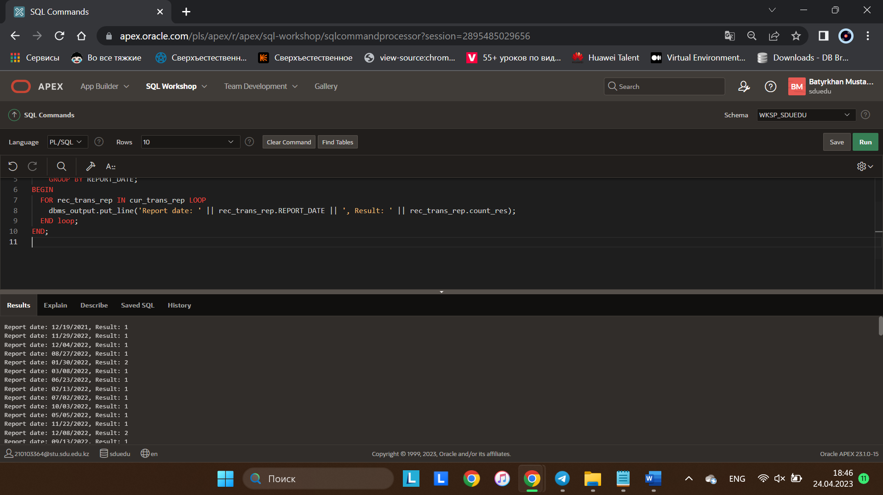

2. Function which counts the number of records:

DECLARE

rec_count INTEGER;

BEGIN

SELECT COUNT(*) INTO rec_count FROM ADMIN;

DBMS_OUTPUT.PUT_LINE('Number of records: ' || rec_count);

END;

// This procedure counts all administrators that we have

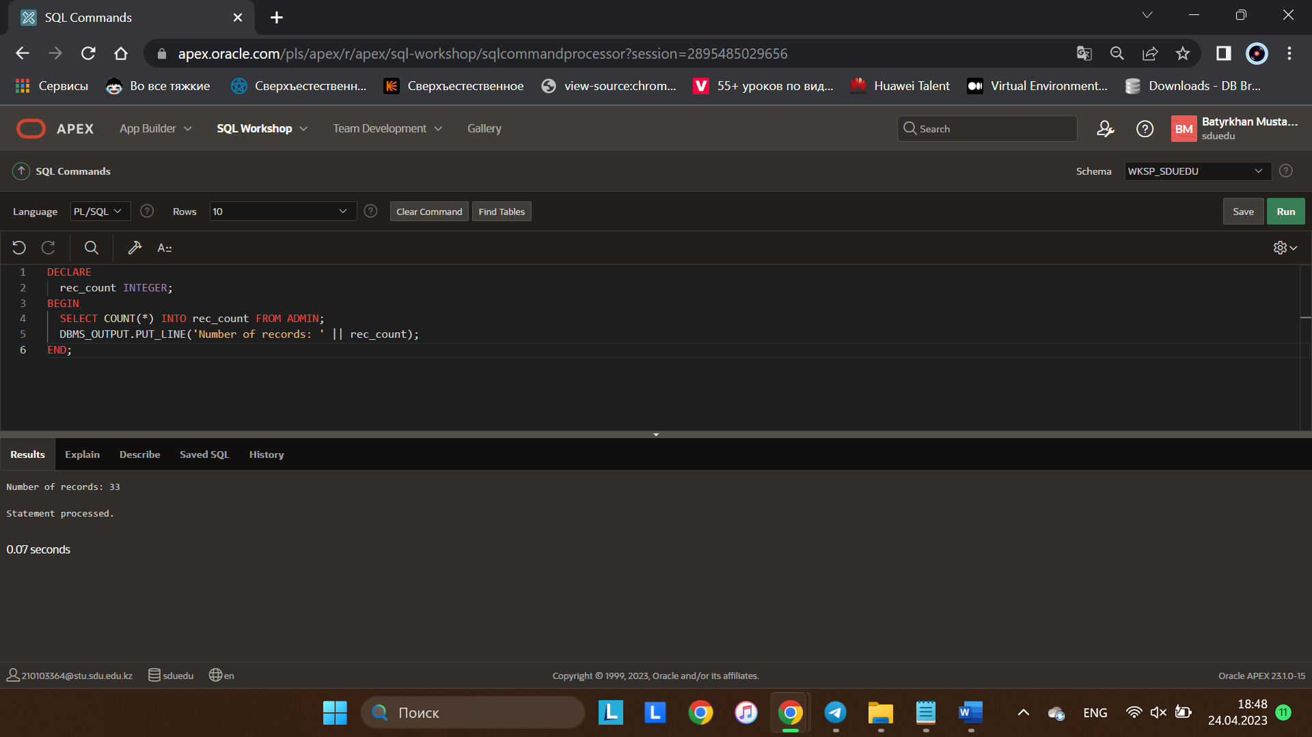

3. Procedure which uses SQL%ROWCOUNT to determine the number of rows affected:

CREATE OR REPLACE PROCEDURE rowscount

AS

i NUMBER;

BEGIN

UPDATE BRAND

SET brand_name = brand_name + '_save_animals!'

WHERE COMPANY_ID = 12;

i := SQL%rowcount;

dbms_output.put_line(i);

END;

// A certain company, if desired, can start presenting its products as brands of a charity organization by adding the slogan “save_animals” to the name

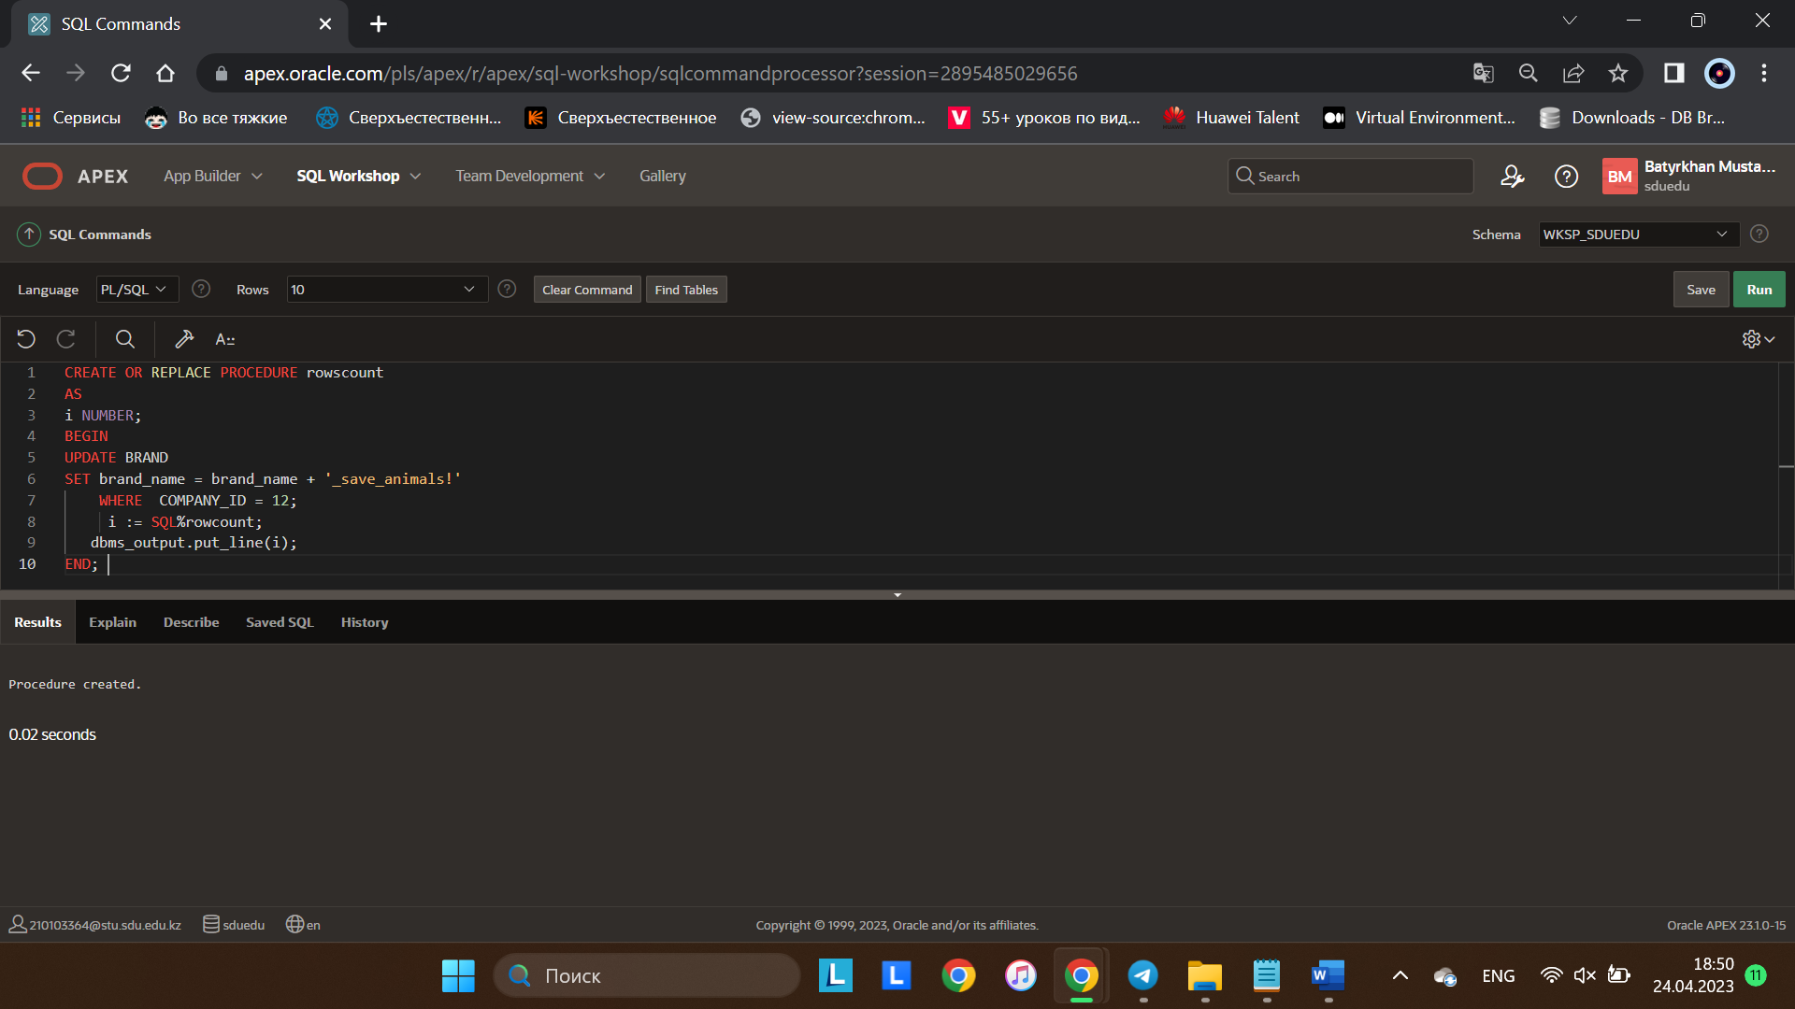

4. Add user-defined exception which disallows to enter title of item (e.g. book) to be less than 5 characters:

DECLARE

less_than_5_character EXCEPTION;

title Website.website_name%type;BEGIN

BEGIN

IF LENGTH( title ) < 5 THEN

RAISE less_than_5_character;

END IF;

EXCEPTION

WHEN less_than_5_character THEN

dbms_output.put_line('TITLE_CANNOT_BE_LESS_THAN_5_CHARACTER');

RAISE;

END;

EXCEPTION

WHEN less_than_5_character THEN

RETURN;

COMMIT;

END;

// A special exception that will rise if the length of the entered site name in the website table does not reach the norm (there are 5 letters here)

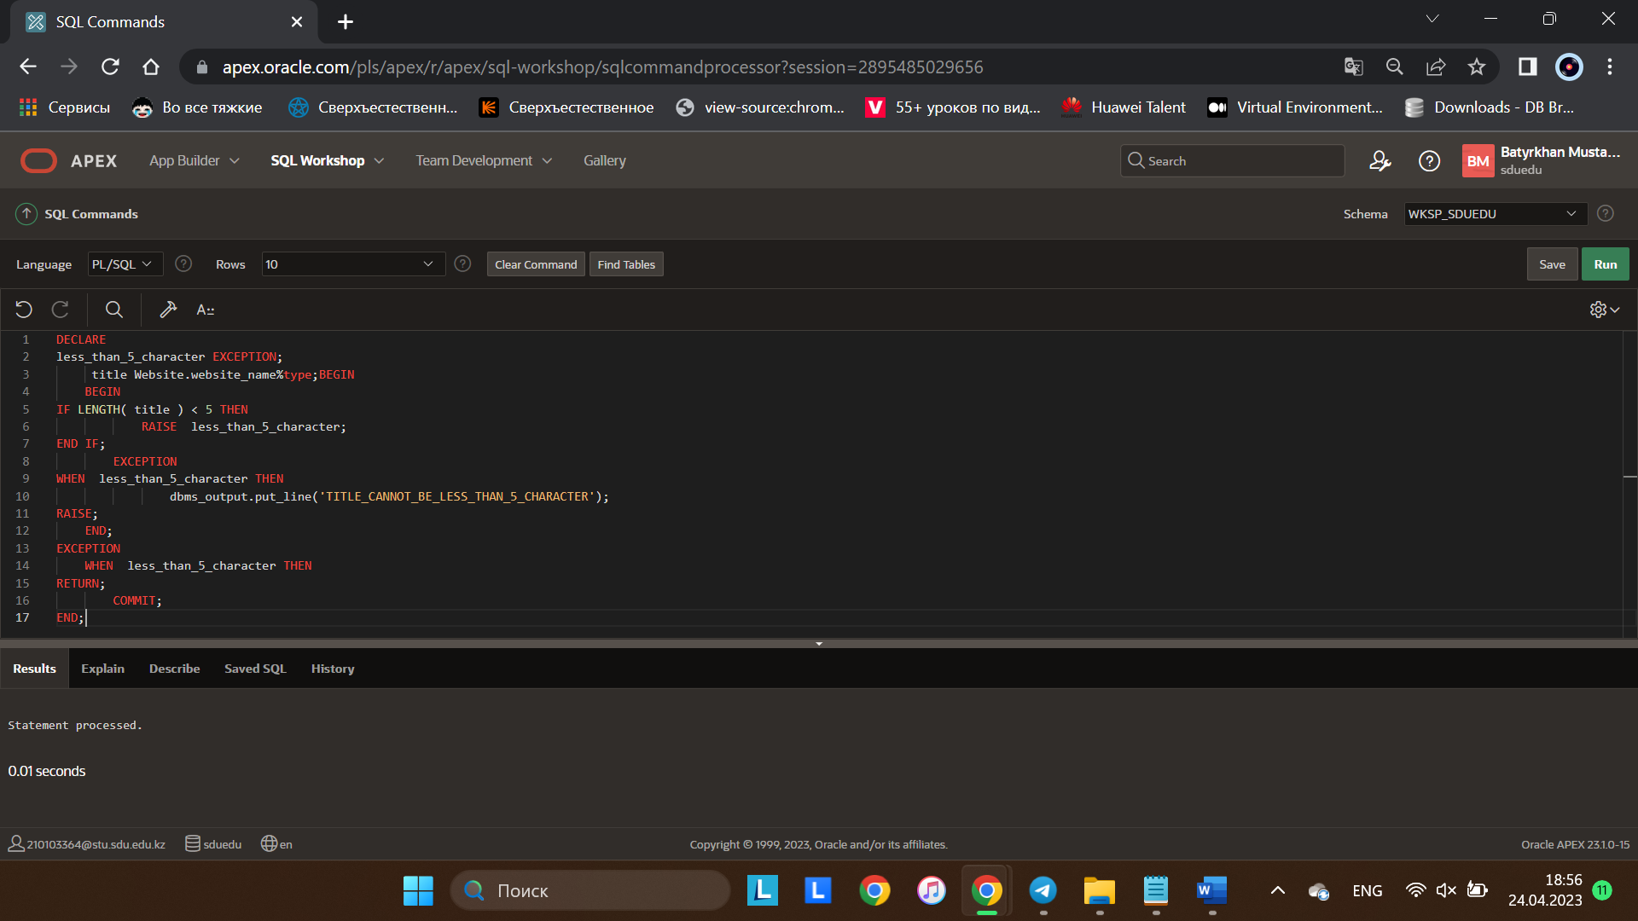

5.Create a trigger before insert on any entity which will show the current number of rows in the table:

CREATE OR REPLACE TRIGGER NUMBER_OF_TRANSACTIONS

BEFORE INSERT ON TRANSACTION_REPORT

DECLARE

RES INT;

BEGIN

SELECT count(*) INTO RES FROM TRANSACTION_REPORT;

DBMS_OUTPUT.PUT_LINE(RES);

END;

// A trigger that will output the number of transactions in the table before entering a new element

